Order Of Service

Singing: Psalm 114—CW page 92

Reading: Psalm 114

Opening Hymn: TLH 237

Reading: Acts 28

Request Hymn: CW Supplement 766

Reading: Matthew 13:18-23

Sermon Hymn: TLH 236

Sermon Text: Mark 12:38-40

Beware Of The Scribes

Prayer

The Apostles’ Creed, TLH page 12

Holy Communion

The Lord's Prayer

The Blessing

Closing Hymn: TLH 234

* * * * * * * * * * *
Bible Study: Lambs: Raccoon
Sheep: Proverbs 22:16-21
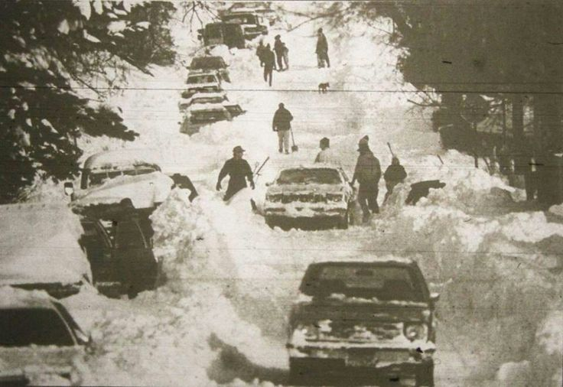

Been There, Done That—Duluth, MN

Water
Of
Life

16 February 2020

W A T E R O F L I F E

Independent Christian Church—Conservative Lutheran Doctrine

Worship Service: 9:30 a.m. Bible Study: 10:45 a.m.

Larry Cooper, Pastor E-Mail address:
111 N. Ridge Road lcooper@wateroflife.cc
Coon Valley, WI 54623 Web Site:
www.wateroflife.cc

* * * * * * * * * * * * * * * * * * * * * * * * * * *

Sermon Text: Mark 12:38-40

Beware Of The Scribes

* * * * * * * * * * * * * * * * * * * * * * * * * * *

Mark 12:38 And he said unto them in his doctrine, Beware of the scribes, which love to go in long clothing, and love salutations in the marketplaces,
:39 And the chief seats in the synagogues, and the uppermost rooms at feasts:
:40 Which devour widows' houses, and for a pretence make long prayers: these shall receive greater damnation.

Matthew 23:13 But woe unto you, scribes and Pharisees, hypocrites! for ye shut up the kingdom of heaven against men: for ye neither go in yourselves, neither suffer ye them that are entering to go in.
14 Woe unto you, scribes and Pharisees, hypocrites! for ye devour widows' houses, and for a pretence make long prayer: therefore ye shall receive the greater damnation.
15 Woe unto you, scribes and Pharisees, hypocrites! for ye compass sea and land to make one proselyte, and when he is made, ye make him twofold more the child of hell than yourselves.
16 Woe unto you, ye blind guides, which say, Whosoever shall swear by the temple, it is nothing; but whosoever shall swear by the gold of the temple, he is a debtor!
17 Ye fools and blind: for whether is greater, the gold, or the temple that sanctifieth the gold?
18 And, Whosoever shall swear by the altar, it is nothing; but whosoever sweareth by the gift that is upon it, he is guilty.
19 Ye fools and blind: for whether is greater, the gift, or the altar that sanctifieth the gift?
20 Whoso therefore shall swear by the altar, sweareth by it, and by all things thereon.
21 And whoso shall swear by the temple, sweareth by it, and by him that dwelleth therein.
22 And he that shall swear by heaven, sweareth by the throne of God, and by him that sitteth thereon.
23 Woe unto you, scribes and Pharisees, hypocrites! for ye pay tithe of mint and anise and cummin, and have omitted the weightier matters of the law, judgment, mercy, and faith: these ought ye to have done, and not to leave the other undone.
24 Ye blind guides, which strain at a gnat, and swallow a camel.
25 Woe unto you, scribes and Pharisees, hypocrites! for ye make clean the outside of the cup and of the platter, but within they are full of extortion and excess.
26 Thou blind Pharisee, cleanse first that which is within the cup and platter, that the outside of them may be clean also.
27 Woe unto you, scribes and Pharisees, hypocrites! for ye are like unto whited sepulchres, which indeed appear beautiful outward, but are within full of dead men's bones, and of all uncleanness.
28 Even so ye also outwardly appear righteous unto men, but within ye are full of hypocrisy and iniquity.
29 Woe unto you, scribes and Pharisees, hypocrites! because ye build the tombs of the prophets, and garnish the sepulchres of the righteous,
30 And say, If we had been in the days of our fathers, we would not have been partakers with them in the blood of the prophets.
31 Wherefore ye be witnesses unto yourselves, that ye are the children of them which killed the prophets.
32 Fill ye up then the measure of your fathers.
33 Ye serpents, ye generation of vipers, how can ye escape the damnation of hell

